**CCNA PROJECT - 1**

PROBLEM STATEMENT:

Ping a single device to multiple connected with the switches and get the data from other devices. Use with server and Wifi [AP-PT].

SOLUTION:

Required items:

1. ROUTER - 2
2. SERVER – 1
3. WIFI – 1
4. SWITCH – 3
5. PC – 3
6. TAB – 2
7. PHONE – 1

I’ve been working on CCNA-based projects that involve configuring network connections between various devices such as routers, switches, WiFi, PCs, tablets, and mobile devices.

One of my recent projects focused on DHCP configuration:

* Configured routers to assign IP addresses dynamically within a defined range.
* Connected multiple devices and enabled DHCP to automate IP allocation.
* Successfully tested device-to-device communication using ping to ensure seamless connectivity.

ACHIVED OUTPUT

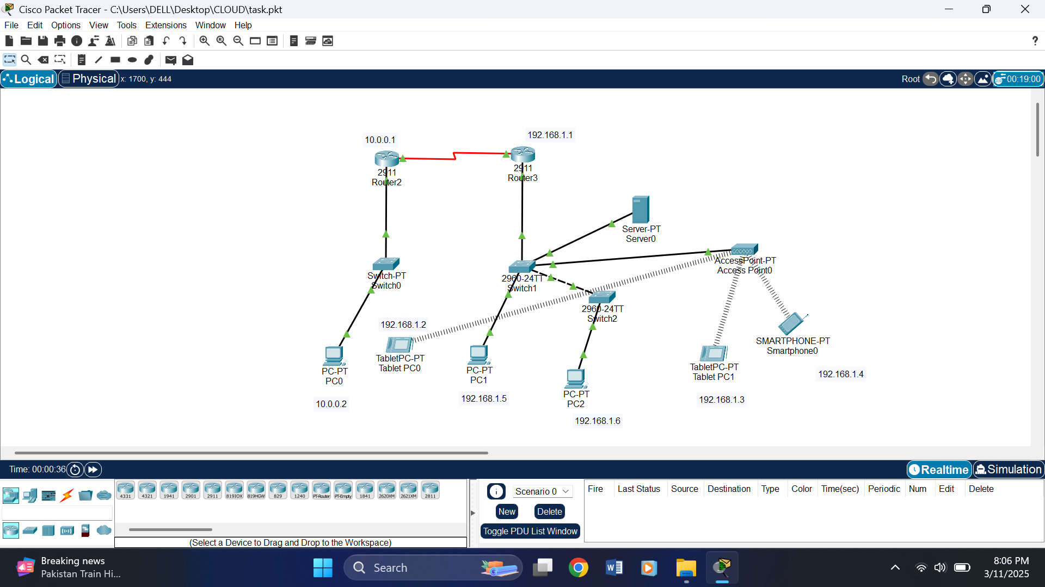

SERVER WILL ASSIGNED AUTOMATTICALLY BY DHCP:

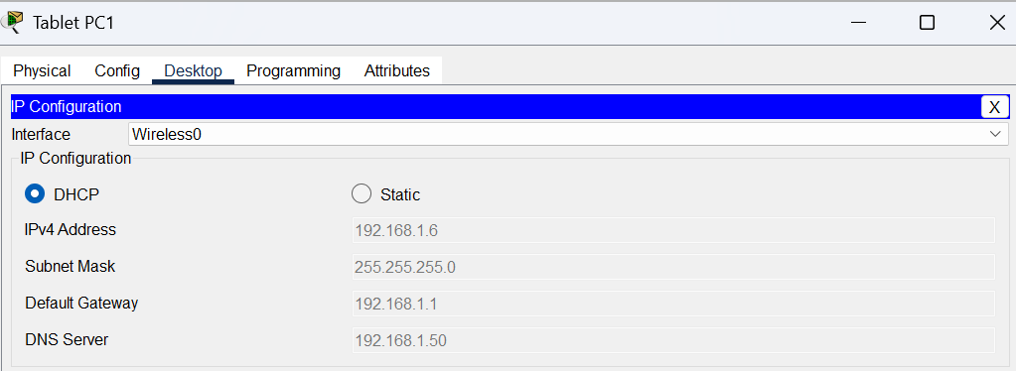

PC1

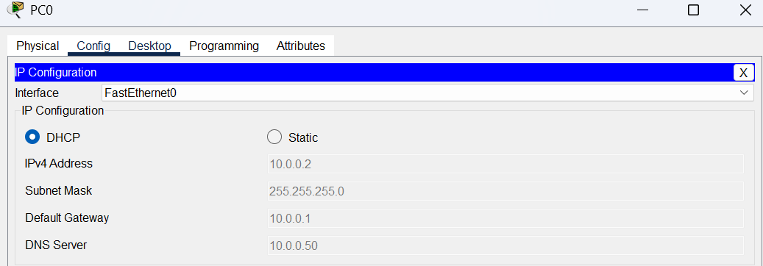

PC0

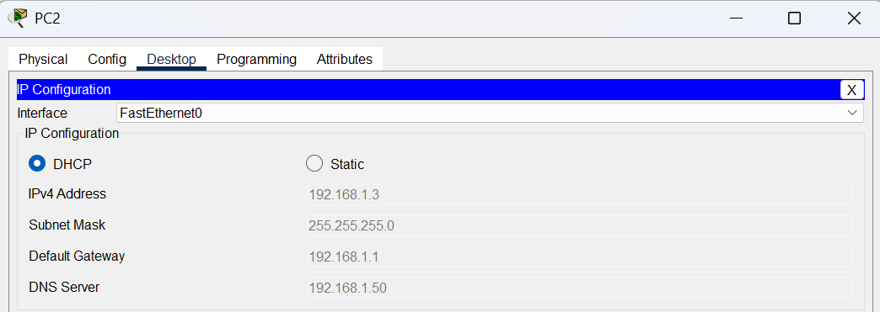

PC2

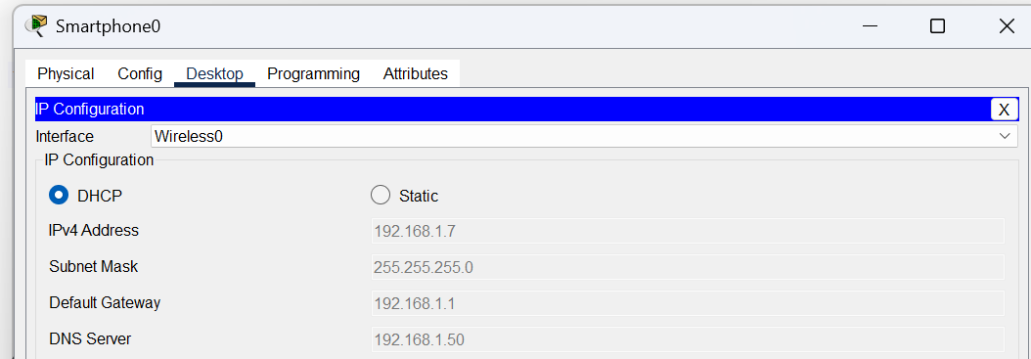

SMARTPHONE 0

ADDED SOME SCREEN SHOTS OF PING TO ANOTHER DEVICES:

1. PC0 TO PC2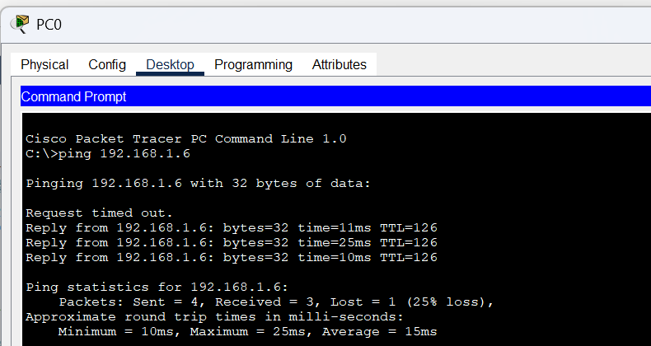
2. TABLET 0 TO TABLET 1

